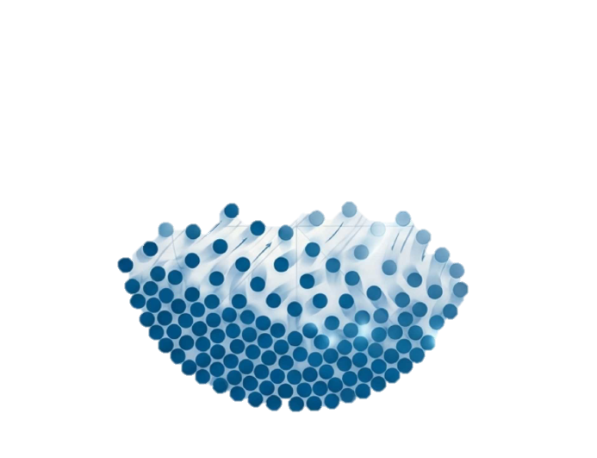

Evaporation


Table of Content
Principle 2
Equipments 3
Evaporation at Atmospheric Pressure 3
Evaporation Pans (Steam-Jacketed Pans) 4
Calandria (Short-Tube Vertical Evaporator) 4
Climbing Film Evaporators 5
Horizontal Film Evaporators 5
Forced-Circulation Evaporator 6
Forced-Circulation Evaporator with External Heating Surface 7
Multiple-Effect Evaporator 7
Entrainment separators 8
Common accessories used with evaporators 9
1. Condensers 9
Surface Condensers 9
Contact Condensers 9
2. Vacuum Pumps and Ejectors 10
Reciprocating Pumps 10
Steam Jet Ejectors 10
3. Steam Traps 11
4. Entrainment Separators 11
5. Salt Removal Equipment 11
6. Foaming Controls 11

Evaporation

Evaporation is the process of turning a liquid (usually water) into vapor to leave behind a solid or a more concentrated liquid. In pharmaceutical manufacturing, we usually let the vapor escape because it is often of little value, which is why it is different from distillation, where the vapor is collected.

Principle
Here are the simple principles that explain how it works:
1. Vapor Pressure and Temperature
Every liquid has a "tendency to evaporate," which is called vapor pressure. As you heat a liquid, its vapor pressure increases. In a closed container, evaporation continues until the air is full of vapor (saturated) and reaches a "maximum vapor pressure".
2. Boiling Point and Pressure
A liquid starts to boil when its vapor pressure equals the pressure of the air or gas around it.
- Vacuum Power: If you lower the pressure (like using a vacuum), the liquid will boil at a much lower temperature. This is useful for medicines that could be destroyed by high heat.
- Depth Effect: In large tanks, the weight of the liquid (called hydrostatic head) adds extra pressure at the bottom. This causes the liquid at the bottom to boil at a higher temperature than the liquid at the top.
3. The Effect of Dissolved Solids
When you dissolve a solid in a liquid, it becomes harder for the liquid molecules to escape. This lowers the vapor pressure and raises the boiling point. This means that as a solution becomes more concentrated during evaporation, it often requires more heat to keep it boiling.
4. Essential Requirements for Evaporation
To keep evaporation going, you must do two main things:
- Supply Constant Heat: You must provide energy (called latent heat) to turn the liquid into gas.
- Remove Vapor: You must constantly clear away the vapor from above the liquid. If the space above the liquid stays full of vapor, evaporation will stop.
5. Heat Transfer Obstacles
Heat usually travels from steam through a metal wall into the liquid. This heat can be blocked or slowed down by:
- Still Films: Thin, stagnant layers of liquid or condensed steam that act like insulation.
- Scale: Dirt or mineral deposits that build up on the metal walls.
- The Wall Itself: The thickness and material of the container wall.
To make evaporation faster, manufacturers try to increase the heating surface area and keep the liquid moving quickly to thin out those stagnant films.
Small-Scale Methods
When working with small amounts of liquid (like in a lab), the following methods are used:
- Equipment: Shallow porcelain or glass dishes are used to provide a large surface area for evaporation.
- Heating: Direct flames (like a Bunsen burner) are generally avoided because as the liquid becomes concentrated, it can easily overheat and burn the medicine.
- Gentle Heat: Instead of a direct flame, water baths or steam baths are used for steady, gentle heat. For even higher temperatures, sand or oil baths are employed.
- Vacuum: If the last bits of liquid are hard to remove or if the medicine is heat-sensitive, the process is finished in a vacuum.
Large-Scale Methods
Moving from a small bowl to a massive factory tank is called "scaling up." It is much more complex because:
- Heating Speed: A large vessel (like a 500-liter tank) heats up much more slowly than a small lab dish because it has much less surface area relative to the amount of liquid inside.
- Open Pans: Simple steam-jacketed pans (like a double boiler) are used for some products, but they require good ventilation so the room doesn't fill with steam.
- Specialized Machines: To handle huge volumes efficiently, factories use advanced equipment like Calandrias (tanks with many heating tubes) or Film Evaporators that spread the liquid into very thin layers to speed up the process.

Equipments

Evaporation at Atmospheric Pressure
- Introduction: On a manufacturing scale, this method is primarily used for aqueous extracts that are not easily damaged by heat.
- Construction: It generally involves the use of open pans or stills. Stills are specifically used for alcoholic solutions so the expensive alcohol can be recovered.
- Working: The liquid is heated until it reaches its boiling point at atmospheric pressure (e.g., 100°C for water). The vapor is allowed to escape into the surrounding air.
- Advantages: It is a simple and inexpensive method for processing materials that are stable at high temperatures.
- Disadvantages: It can be slow, and the escaping vapor can make the working environment humid and uncomfortable.
- Limitations: It is not suitable for heat-sensitive medicines or for recovering expensive solvents.
- Ways to Overcome Limitations: Using efficient ventilation, such as hoods and electric fans, can speed up evaporation by removing saturated air from above the liquid. For heat-sensitive products, evaporation is shifted to vacuum systems.
- Pharmaceutical Applications: Final stages of preparing soft extracts and concentrating aqueous solutions.

Evaporation Pans (Steam-Jacketed Pans)
- Introduction: These are simple, large-scale heating vessels used for evaporating aqueous liquids.
- Construction: They consist of a hemispherical pan made of stainless steel, copper, or aluminum, surrounded by a cast-iron jacket for steam. They vary in depth-to-diameter ratios; shallow pans offer a larger surface area for faster evaporation.
- Working: Steam is admitted into the jacket, transferring heat through the pan's wall to the liquid inside. The liquid is often stirred manually or mechanically to ensure even heating.
- Advantages: Simple construction, low cost, and easy product removal/cleaning.
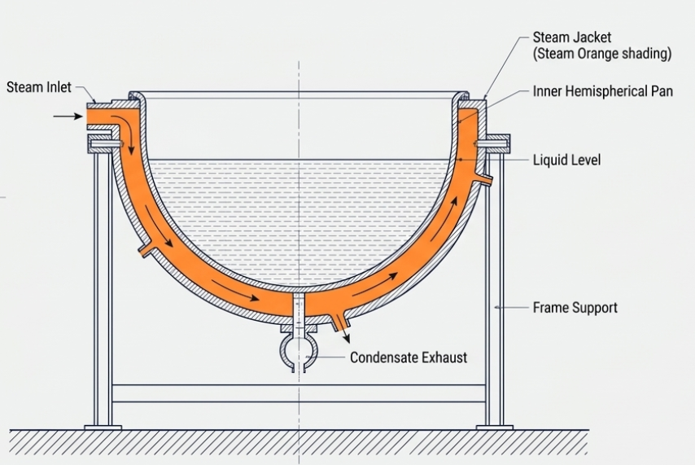
- Disadvantages: They have a limited heating area compared to the volume of liquid, making them slower than specialized evaporators.
- Limitations: Efficiency drops as the liquid becomes concentrated and circulation slows down.
- Ways to Overcome Limitations: Using tilting pans (up to 90L capacity) makes discharging the product easier. Mechanical stirrers can prevent local overheating as the liquid thickens.
- Pharmaceutical Applications: Preparation of soft extracts and bulk aqueous concentration.

Calandria (Short-Tube Vertical Evaporator)
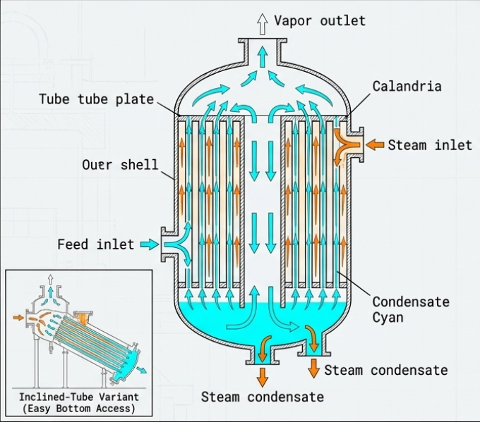
- Introduction: This unit is designed to provide a much larger heating surface than a simple pan by using a bundle of tubes.
- Construction: It consists of a large vessel containing many parallel tubes (approx. 1.2m long and 5cm diameter). These tubes are mounted between two plates to form a unit where liquid is inside the tubes and steam is outside.
- Working: Steam heats the liquid in the tubes, causing it to boil and rise rapidly. The liquid then returns through a large central tube (downcomer), creating a rapid natural circulation.
- Advantages: Large heating surface and rapid circulation, which improves the heat transfer rate.
- Disadvantages: It can be very large (up to 4m in diameter), making it difficult to clean and maintain.
- Limitations: Scaling (solid deposits) can occur inside the tubes, reducing efficiency.
- Ways to Overcome Limitations: Inclined-tube versions allow the tubes to be reached and cleaned more easily.
- Pharmaceutical Applications: Large-scale evaporation of aqueous extracts, such as liquorice.
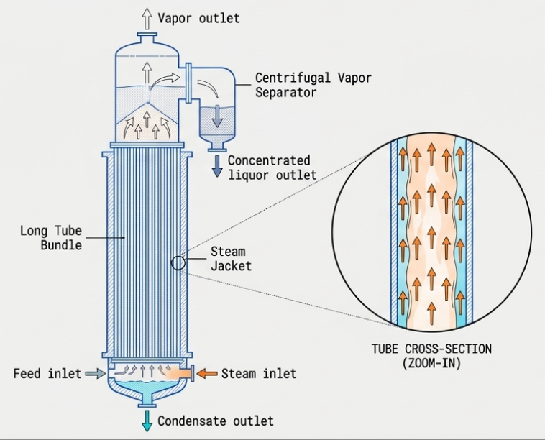

Climbing Film Evaporators
- Introduction: A specialized evaporator that uses long tubes to create a thin film of liquid for extremely fast evaporation.
- Construction: It contains a small number of very long tubes (approx. 6.9m long) encased in a steam jacket, leading to a centrifugal separator.
- Working: Preheated liquid enters the bottom. As it boils, the vapor forms a core in the center of the tube, forcing the liquid to "climb" the walls as a thin film at very high velocities (up to 27m/sec).
- Advantages: The liquid is in contact with the heat for a very short time, and the high velocity reduces scaling.
- Disadvantages: The equipment is very tall and requires significant vertical space.
- Limitations: It requires a minimum feed rate to maintain the film; otherwise, the tubes may run dry and burn the product.
- Ways to Overcome Limitations: Precise control of the feed rate and steam pressure ensures a constant, stable film.
- Pharmaceutical Applications: Concentrating heat-sensitive products and aqueous extracts of liquorice.

Horizontal Film Evaporators
- Introduction: These use horizontal tubes to process liquid in a thin film, often used when metallic contact must be avoided.
- Construction: It consists of several pairs of horizontal concentric tubes connected to form a hairpin coil. The liquid passes through the inner tubes.
- Working: Liquid enters at the bottom and moves upward, while steam moves downward between the inner and outer tubes (counter-current flow). The vapor and liquid are separated at the end.
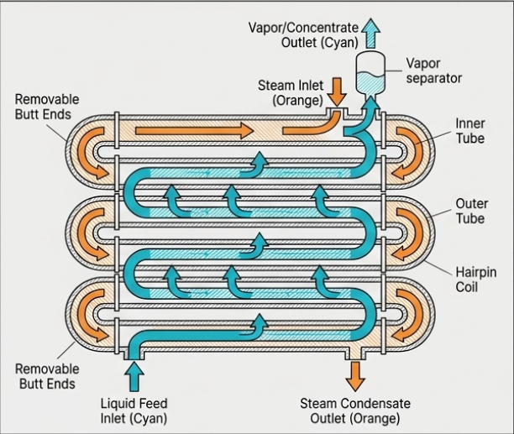
- Advantages: The counter-current principle maximizes heat transfer. They can be made of glass to eliminate metallic contact for sensitive chemicals.
- Disadvantages: They generally have a lower capacity (135–155L/hr) compared to vertical film evaporators.
- Limitations: Cleaning can be tedious if the tubes are not easily accessible.
- Ways to Overcome Limitations: Construction with removable butt ends held by stirrups makes cleaning much easier.
- Pharmaceutical Applications: Concentration of cascara extractive and other specialized extracts.

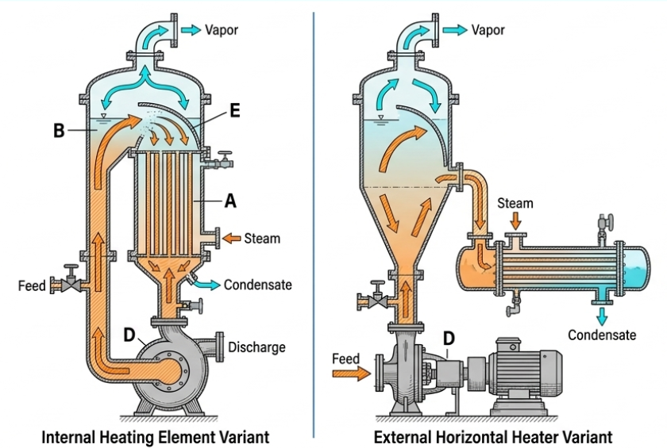
Forced-Circulation Evaporator
- Introduction: This evaporator uses a pump to drive liquid through the heating tubes at high speed, rather than relying on natural boiling.
- Construction: It features long, narrow tubes in a heating element connected to a circulating pump and a vapor head with a deflector.
- Working: The pump delivers liquid through the tubes at a positive velocity. As it boils and exits the tubes, it strikes a curved deflector that separates the liquid from the vapor.
- Advantages: Excellent for viscous or foamy liquids. The high velocity prevents solids from sticking to the tubes (scaling).
- Disadvantages: Higher operational cost due to the continuous use of a pump.
- Limitations: Foaming can still occur if not properly managed.
- Ways to Overcome Limitations: In a forced-circulation evaporator, foaming is primarily managed through mechanical breaking of the foam bubbles using high-velocity impact.
- Pharmaceutical Applications: Concentration of foamy or viscous medicines and solutions that tend to deposit scale or crystals.
The following methods are used to manage foam in these systems:
- Mechanical Impingement: The liquid carrying the foam is ejected at a high velocity from the heating tubes and strikes against a curved deflector or baffle. This physical impact mechanically breaks the bubbles, separating the liquid from the vapor. This feature makes forced-circulation evaporators particularly suited for handling foamy liquids.
- Controlled Liquid Levels: The liquid may be maintained at a level below the top of the heating surface. This ensures that any rising foam bubbles come into contact with the hot surface and burst.
- Steam Jets: In some instances, steam jets may be directed specifically against the layer of foam to break it up.
- Chemical Additives: If mechanical methods are insufficient, small amounts of antifoaming agents can be added to the liquid to control or eliminate foam. These include:
  - Sulfonated castor oil.
  - Cottonseed oil or other vegetable oils.
  - Silicones.

Forced-Circulation Evaporator with External Heating Surface
- Introduction: A variation where the heating unit is completely separate from the main evaporator body.
- Construction: It uses a separate two-pass heater. A pump moves liquid from the body, through the heater, and back via a tangential inlet.
- Working: The tangential inlet causes the liquid in the body to rotate, which helps release vapor bubbles from the surface without carrying liquid droplets with them.
- Advantages: The separate heater is easier to maintain or replace without dismantling the whole system.
- Disadvantages: More complex piping and a larger overall footprint.
- Limitations: High energy consumption for the pump and potential for pressure drops in the external heater.
- Ways to Overcome Limitations: Using a flash chamber design allows for rapid vapor liberation even with high-solids content.
- Pharmaceutical Applications: Concentrating materials that deposit crystalline solids, such as salt brines.

Multiple-Effect Evaporator
- Introduction: A system designed to save money on steam by using the vapor from one evaporator to heat the next one in a series.
- Construction: It consists of several evaporator bodies (effects) connected in a series. The first effect uses "live" steam, while subsequent effects use the vapor produced by the previous one.
- Working: Each subsequent effect operates at a lower pressure than the one before it. This lower pressure lowers the boiling point, allowing the "used" vapor to still be hot enough to boil the liquid in the next tank.
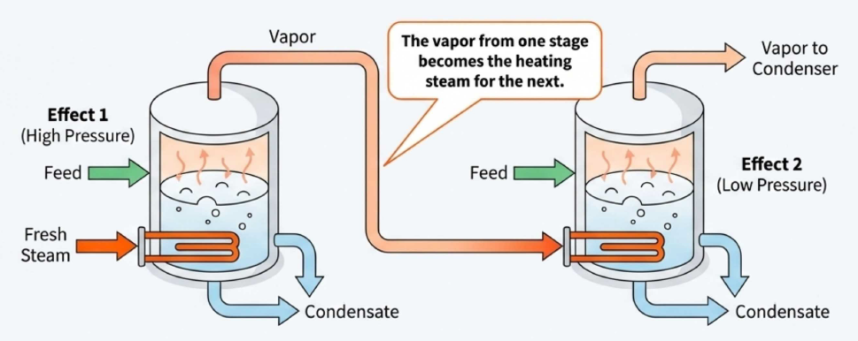
- Advantages: Extreme steam economy; it uses much less fuel than single evaporators.
- Disadvantages: Very high initial investment cost due to multiple units and complex piping.
- Limitations: It does not increase the capacity (total evaporation per hour) significantly; it only increases the economy (efficiency).
- Ways to Overcome Limitations: Finding the optimum number of effects (usually 3 or 4) through an economic balance between steam savings and equipment costs.
- Pharmaceutical Applications: Large-scale manufacturing where steam and water costs are the primary concerns.

Entrainment separators
Entrainment separators play a critical role in evaporation by capturing and recovering fine liquid droplets that are accidentally carried away by the rising vapor stream.
The following sections explain why they are necessary and how they function:
The Problem of Entrainment
When vapor bubbles rise to the surface of a liquid and burst, they project tiny drops of liquid into the vapor stream. If the vapor is moving at a high velocity, it carries these droplets along with it—a phenomenon known as entrainment. This is problematic for two main reasons:
- Product Loss: It can cause a serious loss of the medicinal liquid being evaporated.
- Contamination: It contaminates the condensate, which is an issue if that condensed liquid is intended for other uses.
The Fundamental Role and Principle
While initial separation is attempted by designing large vapor heads to lower vapor velocity and high vapor spaces to allow drops to settle back, droplets that enter the vapor pipe must be removed by specialized separators.
The core principle of these separators relies on momentum: because liquid particles are heavier than vapor, they cannot change direction as quickly. If the vapor stream is forced to hit a solid surface or change direction suddenly, the liquid droplets will impinge (strike) that surface, coalesce (merge) into a sheet of liquid, and drain away rather than being carried further.
Common Types of Entrainment Separators
- Baffles: These are physical barriers placed in the vapor space or within the pipes. The vapor flows around them, while the heavier liquid particles strike the surface and run down.
- Cyclone (Tangential) Separators: Vapor is introduced tangentially into a cylindrical vessel, creating a whirling motion. Centrifugal force throws the liquid droplets against the walls, where they form a sheet of liquid that returns to the evaporator.
- Centrifugal Separators: These often use a cage of spiral vanes to create a strong whirling motion. This motion throws the drops against a wall from which they are returned to the evaporator through a trap.
Note: Although they are sometimes called "foam catchers," the sources clarify that true entrainment separators are generally unable to stop a stable blanket of foam from passing into the condenser if it reaches the vapor pipe.
For concentrating heat-sensitive medicines, the best methods are those that either lower the boiling point through a vacuum or minimize the time the medicine is in contact with heat.

Common accessories used with evaporators
Common accessories used with evaporators are essential devices attached to the main body to ensure efficiency, product recovery, and proper operation under specific conditions. The most common accessories include:

1. Condensers
These are necessary when an evaporator operates under vacuum to condense the escaping vapors. They are classified into two main groups:

Surface Condensers
- Mechanism: The vapor to be condensed and the cooling liquid are separated by a metal wall. They never come into direct contact.
- Construction: These are similar in design to a tubular heater. Usually, the cooling water flows inside the tubes while the vapor remains on the outside. Their efficiency can be improved by increasing the water velocity through a "multipass" design.
- Best Used For: They are essential when the solvent being evaporated is something other than water and needs to be recovered.
- Cost: These are much more expensive to build than contact condensers.

Contact Condensers
- Mechanism: The vapor and the cooling liquid are mixed directly.
- Construction: A common example is the counter-current dry-contact condenser, which consists of a vertical cylinder filled with shelves or baffles. The cooling water cascades down these surfaces while the vapor is introduced at the bottom and passes up through the water "curtains" until it condenses.
- Best Used for: These are almost always used for water vapor because they are simpler and more economical. They are not suitable if you need to recover the condensed vapor in a pure state, as it becomes mixed with the cooling water.
- Cost: These are significantly cheaper and simpler to manufacture.
Feature | Surface Condenser | Contact Condenser
Interaction | Separated by a metal wall | Mixed directly
Purity | Condensed solvent remains pure | Condensed solvent mixes with cooling water
Cost | High | Low
Typical Use | Recovery of non-water solvents | Water vapor removal

2. Vacuum Pumps and Ejectors
These devices remove air and non-condensable gases to maintain the required vacuum within the system.

Reciprocating Pumps
- Mechanism: These are traditional pumps used to remove hot water and non-condensable gases from condensers. They rely on a standard mechanical piston-driven action to create displacement.
- Construction: They are mechanical devices with multiple moving parts, which necessitates regular maintenance and repair.
- Usage: They are often paired with parallel-current wet condensers, where the pump’s displacement must be large enough to handle both the cooling water and the air simultaneously.

Steam Jet Ejectors
- Mechanism: Instead of mechanical movement, these use the kinetic energy of steam. High-pressure steam is forced through a nozzle, creating a jet of very high velocity that is directed into a venturi-shaped tube. This high-speed jet entrains (pulls along) the non-condensable gases from the vacuum space.

Feature | Reciprocating Pump | Steam Jet Ejector
Moving Parts | Contains many moving parts. | No moving parts, which greatly reduces the need for repairs.
Efficiency at High Vacuum | Less efficient at very high vacuum levels. | Practically the only possible device for very high vacua (over 28.5 inches).
Steam Economy | Uses more steam than ejectors at higher vacuum levels. | Uses less steam than a steam-driven vacuum pump for vacua of 26 inches or more.
Maintenance | Requires regular mechanical upkeep. | Minimal maintenance due to its simple, static design.

3. Steam Traps
A steam trap is fitted to the outlet of the heating element to control the discharge of condensate (water) while preventing live steam from escaping.
- Bucket Traps: These use a floating bucket that sinks to open a valve when full of water.
- Thermostatic Traps: These operate based on temperature changes, using a flexible metal capsule to open and close the valve.

4. Entrainment Separators
Also known as "foam catchers," these are used to capture fine liquid droplets that the vapor stream accidentally carries away.
- Cyclone Separators: These introduce vapor tangentially to create a whirling motion, using centrifugal force to deposit liquid droplets on the walls.
- Baffles: Physical barriers placed in the vapor path to force liquid particles to hit the surface and merge into a drainable sheet.

5. Salt Removal Equipment
For liquids that precipitate solids during concentration, specific accessories are used to remove crystals without stopping the process:
- Salt Receivers and Filters: These are attached to the bottom of the evaporator (often a conical bottom) where salt collects and can be pumped out or raked away.
- Salt Elevators: A now largely obsolete method for discharging salt from the bottom of the unit.

6. Foaming Controls
While often handled through design, specific accessories can be used to manage foam:
- Steam Jets: Directed against the foam layer to break bubbles.
- Deflectors/Baffles: Used in forced-circulation evaporators to mechanically break foam through high-velocity impact.
Raoult’s Law explains the boiling point of solutions by describing the relationship between dissolved substances and vapor pressure. According to the sources, the law states that for dilute solutions of nonvolatile solutes, equal amounts of different substances (equimolecular quantities) dissolved in the same volume of a solvent will lower the vapor pressure by the same amount.
This lowering of vapor pressure directly affects the boiling point in the following ways:
- Boiling Point Elevation: When a substance is dissolved in a liquid, the vapor pressure of that liquid is lowered. Because a liquid only boils when its vapor pressure reaches the level of the external atmospheric pressure, a solution with a lowered vapor pressure requires more heat to reach that point. Consequently, the boiling point of the liquid is raised.
- Concentration Effect: As evaporation continues and a solution becomes more concentrated, the boiling point continues to rise. This is a critical consideration in pharmaceutical manufacturing to avoid "serious overheating" of the medicine as the solvent level drops.
- Scientific Application: This predictable relationship between the amount of solute and the change in boiling point forms the basis of the ebullioscopic method, which is used for determining the molecular weight of substances.

